**Part I**

1. It is………?
2. Leg
3. Mouth
4. Lip
5. Cheek
6. 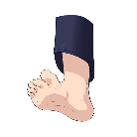It is……….?
7. Cheek
8. Stomach
9. Lip
10. Leg
11. It is…….?
    1. Stomach
    2. Eye
    3. Lip
    4. Cheek
12. What do you use for walking?

I use my…….for walking

1. Leg
2. Lip
3. Ear
4. Mouth
5. What do you use for seeing?

I use my………for seeing

1. Leg
2. Ear
3. Eyes
4. Mouth
5. What do you use for smelling?
6. Nose
7. Leg
8. Eyes
9. Mouth
10. What do you use for eating?
11. Nose
12. Tongue
13. Eyes
14. Mouth
15. How many hands do you have?

I have …….hand

1. One
2. Two
3. Three
4. Four
5. What vegetable is it?
6. Onion
7. Corn
8. Carrot
9. Cabbage
10. What vegetables is it?
11. 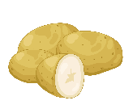Carrot
12. Potato
13. Mushroom
14. Cucumber
15. Do you like….?
16. Corn
17. Potato
18. Eggplant
19. Garlic
20. What is he ….?
21. Driver
22. Fisherman
23. Bricklager
24. Soldier
25. What is he….?
26. Sailor
27. Driver
28. Bricklager
29. Soldier
30. What is he….?
31. Teacher
32. Doctor
33. Police
34. Sailor
35. 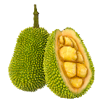What is it …?
36. Cherry
37. Apple
38. Jackfruit
39. Manggosten
40. Translate these sentences in to Indonesia

“My mother make an orange juice”

1. Ayah saya membuat jus jeruk
2. Ibu saya membuat sebuah jus jeruk
3. Ayah mu membuat jus jeruk
4. Ibu mi membuah sebuah jus jeruk
5. Arrange this word into good sentences

We-the-wear-in-ring-finger

1. We ring the finger wear in
2. We wear in ring the finger
3. We wear ring in the finger
4. We the finger wear in ring
5. 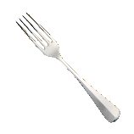Is it a fork?
6. Yes, it is
7. No, it is not
8. Yes, he is
9. No, he is not
10. 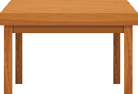Is it a table?
11. Yes, she is
12. No, she is not
13. Yes, it is
14. No, is it not
15. My father reads a … every morning
16. Book
17. Newspaper
18. Radio
19. Magazine

**Part II**

**My Family**

This is my family. My name is Rio. I heve brother and sister. They Ryan and Ria. Ricis is tall, but Ricis is short. My Father is Mr.Ahmad. He is a doctor. My Mother is Mrs.Ahmad. She is a housewife. My grandfather is Mr.Budi. My grandmother is Mrs.Budi. They are old. I have an uncle and an aunt. My uncle is Mr. Naufal. He is teacher. My aunt is Mrs.Naufal. She is a teacher too. Their daughter is Qiana. She is my cousin.

1. Who is Mr.Ahmad ?
2. What does he do?
3. Who is Mr.Naufal?
4. What does he do?
5. Who is Qiana?